* Below is the Dashboard created for a company’s Capstone which includes rating distribution along with corresponding orders, the top 10 and bottom 18 most popular product categories, total number of active sellers by yearly and monthly, payment methods are most commonly used by ShopNest customers, product category. wise profit margin, monthly payments made by customers using credit cards, sellers categorized by city, excluding cities starting with the letters S and B, the number of delayed orders to the number of orders received earlier for each month.

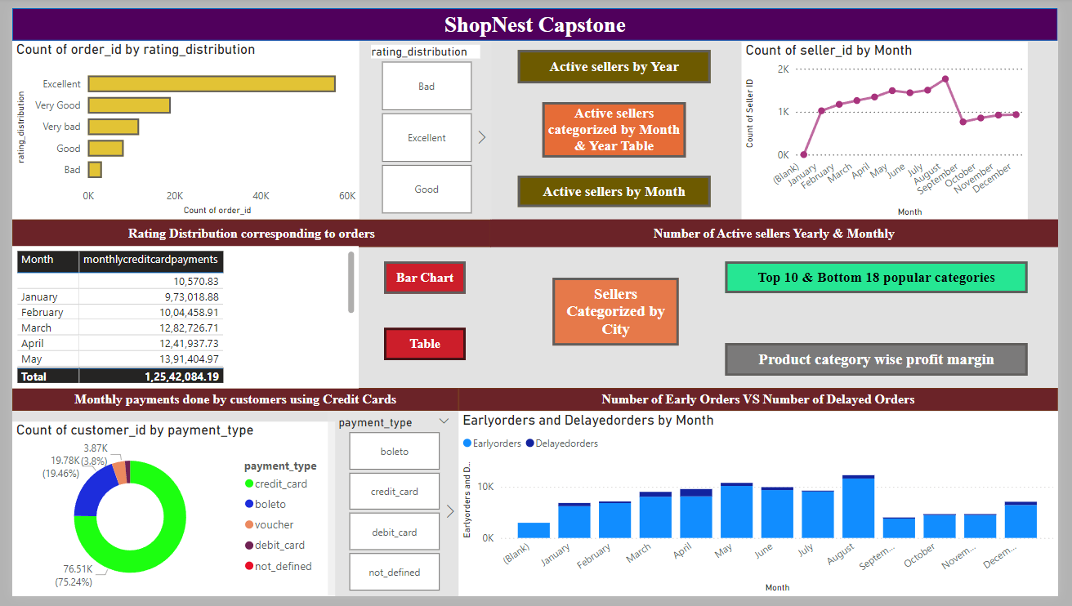

1. **Question Statement -** Identify the rating distribution in the Shop_Nest dataset, showcasing ratings categorized as Excellent, Very Good, Good, Bad, and Very Bad, along with corresponding orders.

**Visualization**

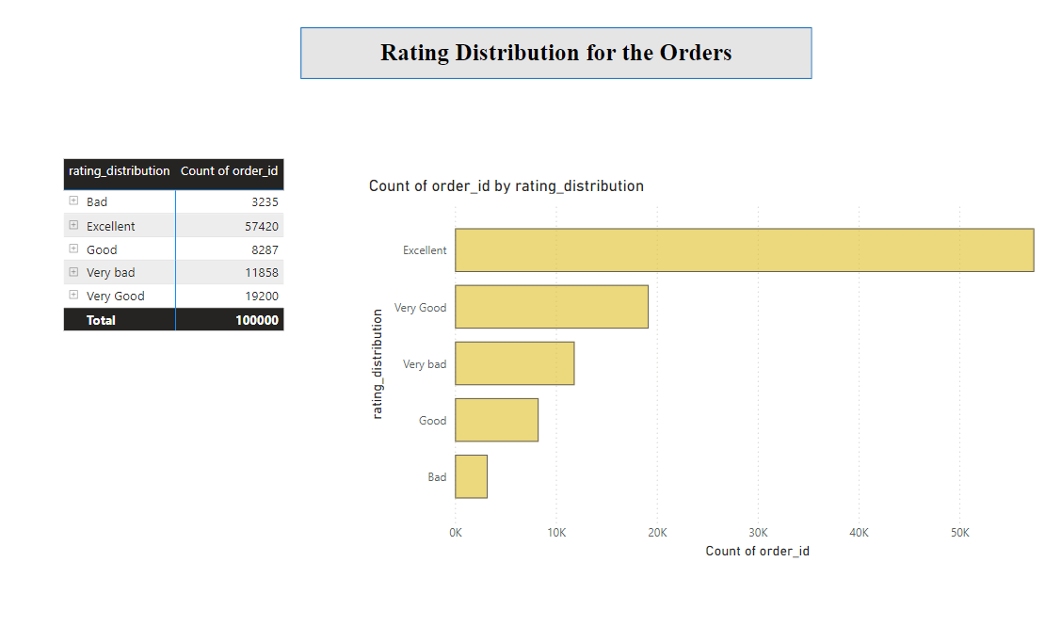

**Explanation –**

**From the graph its been observed that most of the orders are rated excellent & very good & few amount of orders are rated bad. While a quite large amount of orders are rated very bad. Need to focus on converting this very bad while making sure the orders are delivered on time or before the delivery date.**

**2) Question Statement -** What are the top 10 and bottom 18 most popular product categories in the ShopNest dataset? Please list them based on the number of orders.

**Visualization**

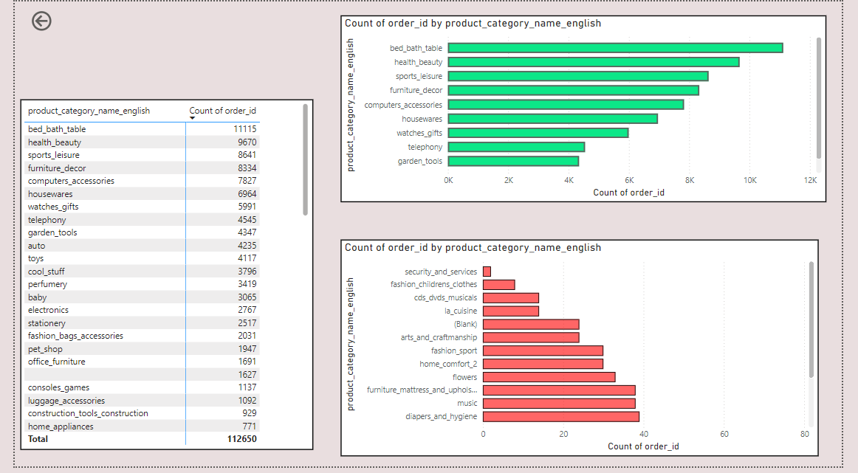

**Explanation –**

**As per the dataset bed bath table, health beauty, sports leisue, furniture décor, computer accessories, housewares. Watch gifts, telephony & garden tools are the top 10 popular categories ordered from the ShopNest**

**Security & Services, Fashion childrens clothes, CD’s, DVD’s & Musicals, La Cusine, Blanks( which doesn’t have any category name, Arts & Craftsmanship, Fashion sport, Home comfort, Flowers, Furniture matress, Music, Diapers & Hygiene, party supplies, fashio female clothing, books imported, DvD’s blue ray, Cine photo are the bottom 18 product categories ordered from the ShopNest**

1. List the total number of active sellers by yearly and monthly.

**Visualization**

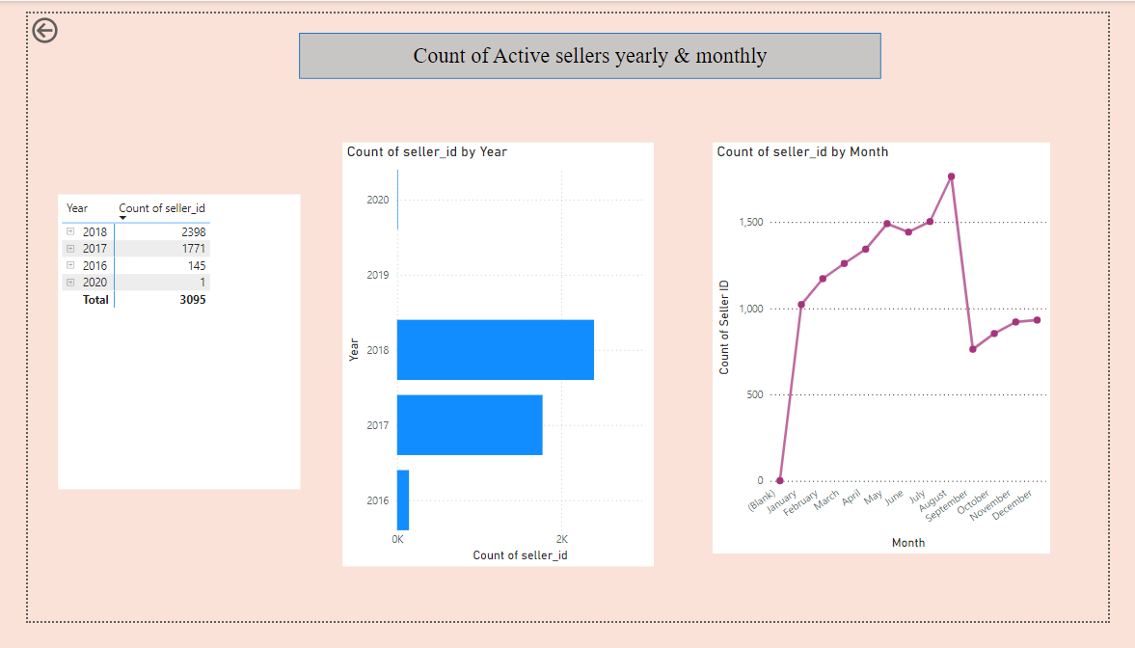

**Explanation –**

As per the graph its been observed that the count of active sellers has gradually been increased from 2016. As there were only 145 sellers in 2016 from where there has been a gradual increase in the sellers from 145 to count of 1771 & then 2398 in 2018 which has been increased due to the increase in the orders too through the ShopNest year by year.

When tasking month into consideration its been observed that August is the month where most of the orders are placed & delivered hence the count of the sellers is high in the month of August & low in the month of September when compared to other month’s

1. Which payment methods are most commonly used by ShopNest customers.

**Visualization**

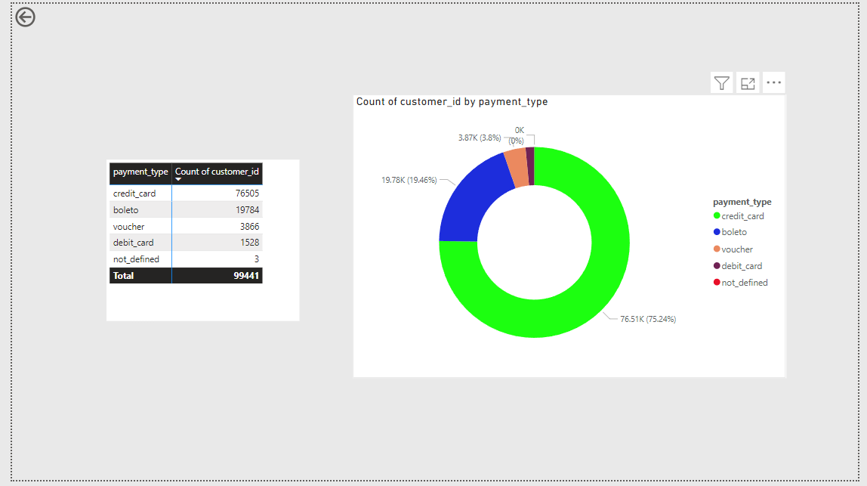

**Explanation – Credit cards are the most used payment type by Shop Nest customers.**

1. Identify the product category. wise profit margin using the formula

**Visualization**

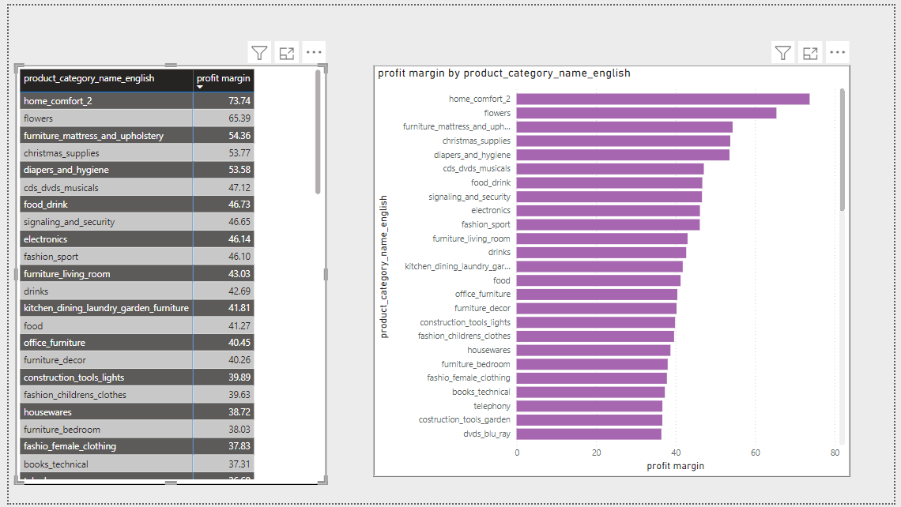

**Explanation – As per the analysis Home comfort 2 has the highest profit margin when compared to other categories & computers have the lowest profit margin.**

1. Determine the monthly payments made by customers using credit card

**Visualization**

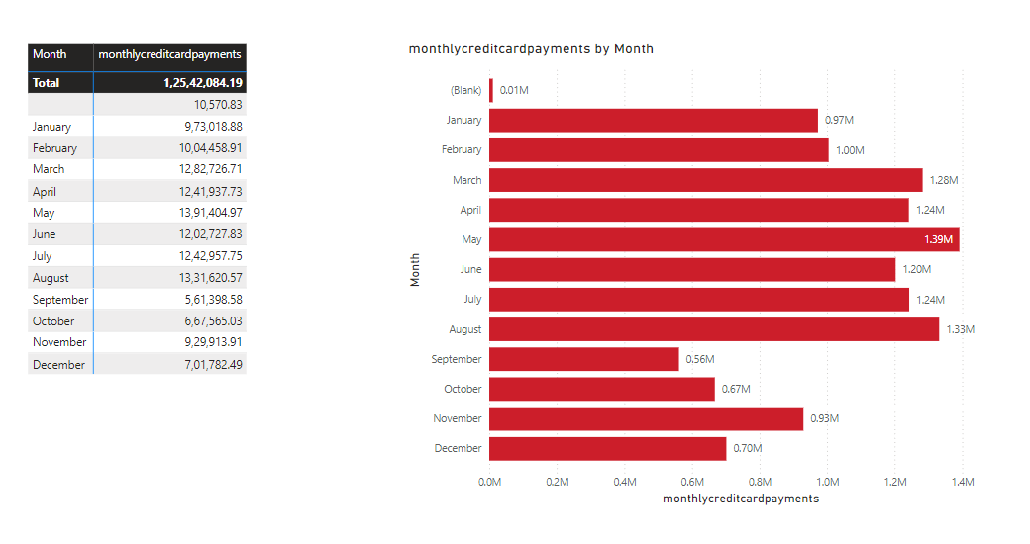

**Explanation – From the analysis its been found that the most of the customers payment has been in the mode of Credit card in the month of May & less in the month of September.**

1. Identify sellers categorized by city, excluding cities starting with the letters S and B.

Visualization

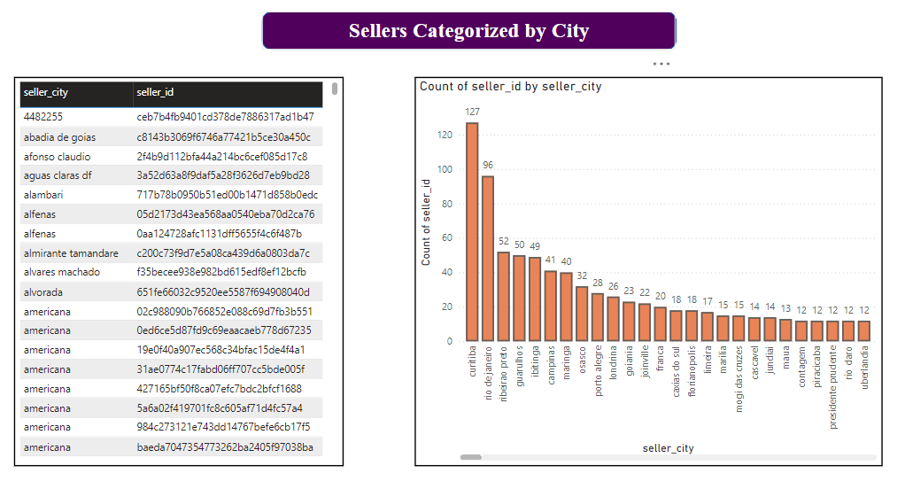

**Explanation** -

From the analysis its been observed that curit iba is the city where there are most number of the sellers with the total count of 127.

1. Create a dynamic visual that compares the number of delayed orders to the number of orders received earlier for each month. Utilize the drill through the cross-report feature to provide a detailed analysis of late and on-time deliveries.

**Visualization**

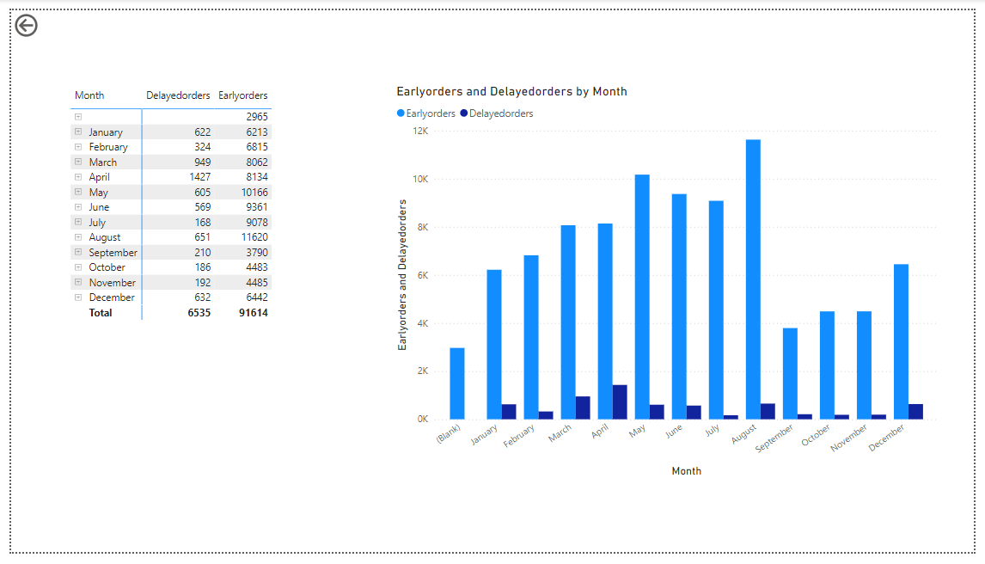

**Explanation** -

From the graph its been observed that most of the orders are delayed in the month of April & most of the early orders are in the month of August.